
CSA15 – CLOUD COMPUTING AND BIG DATA ANALYTICS

ASSIGNMENT 1 – CO1
Design, Analyse and Validate a Cloud-Based Solution for Migrating a Legacy University Management System
CO1: Apply cloud computing technologies including hardware–software evolution, virtualization, web services, and service models to develop cloud-based solutions.
Field | Details | Field | Details
Student Name |  | Register Number
Department / Section |  | Academic Year / Semester
Faculty Name |  | Nature of Assignment | Individual
Duration | 1 Week | Total Marks | 50
Submission Date |  | Evaluation Date
MARK SHEET (Rubric-based evaluation)
Task | Title | Max | Awarded | Evidence / evaluation focus
1 | Introduce Cloud Computing | 3 |  | Definition; characteristics; deployment models; scenario mapping
2 | Trace Evolution and Hardware Evolution | 3 |  | Timeline; hardware evolution; relevance to university
3 | Analyse Internet Software Evolution | 3 |  | Web/software evolution; SOA; APIs; scenario relevance
4 | Apply Server Virtualization | 5 |  | Hypervisor types; VM/container comparison; consolidation;  limitations
5 | Apply Web Services | 4 |  | SOA and SOAP/REST; three university APIs; request/response examples
6 | Analyse IaaS, PaaS and SaaS | 5 |  | Responsibility layers; five-application mapping; comparison; providers
7 | Examine XaaS | 3 |  | Four or more variants; two justified choices; provider risks
8 | Design Cloud Solution | 5 |  | Labelled diagram;
 | Architecture |  |  | deployment/service models; scaling; security; DR
9 | Hands-on Implementation and Documentation | 4 |  | Running VM/container; PaaS/SaaS; tests; actual screenshots
10 | Evaluate and Recommend  Final Solution | 7 |  | Three-way comparison; 3-year costs; risks; phased roadmap
11 | Day-4 Design Challenge | 8 |  | Impact; evaluation; adaptation; evidence-based defence
 | TOTAL | 50 |  | Percentage :
EVIDENCE VERIFICATION CHECKLIST
Tasks | Evidence expected | Status (✓ / P / ✗) | Evaluator note
1–3 | Conceptual explanations, comparisons and relevant illustrations | ✓ | Explanations and relevant scenario mapping documented
4 | Virtualization calculations with stated assumptions and peak-load caution | ✓ | Calculations present; practical capacity validation  recommended
5–7 | API examples, service responsibility table and justified XaaS choices | ✓ | Required conceptual evidence documented
8 | Labelled architecture diagram, caption below figure and component justification | ✓ | Architecture documented; sizing assumptions need testing
9 | Actual code, environment details, execution logs, API outputs and screenshots | P | Procedures provided; actual execution evidence not established
10 | Cost assumptions, 3-year totals, risk controls and migration roadmap | ✓ | Estimates and rationale documented
11 | Day-4 changes, 10× load strategy,  99.9% target and 40-college isolation | ✓ | Design analysis documented; practical validation pending
IMPLEMENTATION EVIDENCE CHAIN
Evidence item | Status | Observation
Source code | ✓ | Flask REST API and Dockerfile provided in the proposed implementation
Virtualization | P | Docker container configuration documented; running-container evidence required
PaaS or SaaS | P | Managed web-service deployment procedure described; live deployment not verified
Functional test | P | Expected HTTP 200 response and JSON output documented; actual output required
Failure case | P | HTTP 404 test case documented; actual execution record required
Screenshots | P | Screenshot requirements identified; authentic screenshots need verification
Reproducibility | ✓ | Build commands, run commands, endpoints and expected results specified
OVERALL REMARKS
_______________ Student Signature | _______________ Faculty Signature | _______________ Program Director
MANDATORY SUBMISSION EVIDENCE CHECK
✓ = Present in documented answer; P = Partly present; ✗ = Missing / not satisfied
Task | Evidence expected | Status | Evaluator note
1 | Cloud definition, characteristics, deployment models and scenario mapping | ✓ | All conceptual requirements covered
2 | Evolution timeline, hardware development and university relevance | ✓ | Well explained with relevant examples
3 | Internet software evolution, SOA and APIs | ✓ | Clear explanation and scenario relevance
4 | Hypervisors, VM/container comparison and consolidation calculations | ✓ | Calculations included; peak-load limitations discussed
5 | SOAP/REST comparison and three university APIs | ✓ | API methods and request/response examples documented
6 | IaaS/PaaS/SaaS responsibility layers and application mapping | ✓ | All five applications categorized with justification
7 | XaaS variants and two justified selections | ✓ | Six variants explained; DBaaS and DRaaS recommended
8 | Labelled architecture, scaling, security and disaster recovery | ✓ | Design and component justifications documented
9 | Working container, PaaS/SaaS deployment, actual tests and screenshots | P | Code and procedures provided; actual execution evidence requires verification
10 | Three-year cost comparison, risks and migration roadmap | ✓ | Cost assumptions, calculations and recommendations included
11 | Impact analysis, 10× load, 99.9% availability and tenant isolation | ✓ | Changed requirements evaluated; loadtest evidence recommended
IMPLEMENTATION EVIDENCE CHAIN
Evidence item | Status | Observation
Source code | ✓ | Python Flask REST API and Dockerfile documented
Virtualization | P | Docker build and run procedures provided; execution screenshot required
PaaS or SaaS | P | Cloud deployment steps described; actual deployment confirmation required
Functional test | P | HTTP 200 and expected JSON response documented; actual
 |  | test output required
Failure case | P | HTTP 404 test case included; execution evidence required
Screenshots | P | Required screenshots identified but authenticity and completeness not verified
Reproducibility | ✓ | Installation, configuration, commands and testing steps documented
Interpretation | ✓ | Technical outcomes and implementation limitations explained
Code and report consistency | ✓ | Proposed API, Docker configuration and testing procedure are aligned
SUBMISSION CHECKLIST (Not Separately Marked)
Requirement | Status
All 11 tasks answered | ☒ Yes ☐ Partly ☐ No
Cloud concepts and comparisons explained | ☒ Yes ☐ Partly ☐ No
Virtualization calculations included | ☒ Yes ☐ Partly ☐ No
API examples and service models explained | ☒ Yes ☐ Partly ☐ No
Cloud architecture diagram included | ☒ Yes ☐ Partly ☐ No
Implementation and testing evidence provided | ☐ Yes ☒ Partly ☐ No
Three-year cost analysis and roadmap included | ☒ Yes ☐ Partly ☐ No
Day-4 design challenge completed | ☒ Yes ☐ Partly ☐ No
Figures and screenshots included | ☐ Yes ☒ Partly ☐ No
Table and figure numbering correct | ☐ Yes ☒ Partly ☐ No
Viva recommended | ☒ Yes ☐ No

CSA15 – Cloud Computing and Big Data Analytics
ASSIGNMENT 1
CO1: Apply cloud computing technologies including hardware–software evolution, virtualization, web services, and service models to develop cloud-based solutions.

Assignment Title: Design, Analyse and Validate a Cloud-Based Solution for Migrating a Legacy University Management System (Total Marks – 50)
Duration: 1 week

Scenario – Smart Campus Cloud Migration
A multi-campus university currently runs its Student Information System, Learning Management System, Library System, Exam Portal and Email on ageing physical servers in a single on-premise data centre. Each application has its own dedicated server, which stays idle for most of the year but fails to cope during admissions, result publication and online-exam weeks.
The university's current environment is:
- 12 physical servers, average CPU utilisation of about 15%, with peaks above 95 % during admissions and exams
- Approximately 25,000 students and 2,000 staff across 4 campuses
- Applications built as large monolithic programs, with no public interfaces for mobile apps or partner colleges
- High capital expenditure, slow procurement (6–8 weeks per server) and no disaster recovery site
As a cloud consultant, you must study how computing evolved to the cloud model, and then design a cloud-based solution that uses virtualization, web services and an appropriate mix of service models (IaaS, PaaS, SaaS and XaaS) for the university. All recommendations must be justified in terms of cost, scalability, availability and manageability.
Design Challenge:
On Day 4, the university announces that it will launch a mobile app and open student-record and fee-payment services to 40 affiliated colleges. Expected load is 10 times the current peak, with a requirement of 99.9% availability and a limited operating budget. Re-evaluate your original design and decide whether it should be retained, modified or redesigned.

TASK 1 – Introduce Cloud Computing and Map It to the Scenario (3 Marks) Design and Propose cloud computing model for the context of the university's problems.
- Definition of cloud computing and the five essential characteristics (ondemand self-service, broad network access, resource pooling, rapid elasticity, measured service)
- Deployment models (public, private, hybrid, community) and which one suits the university
- Three problems of the current on-premise setup and how each cloud characteristic addresses them
- Benefits and limitations of cloud adoption for the university
Evidence Expected
A clear explanation of cloud characteristics and deployment models, mapped to the university's actual problems.

TASK 2 – Trace the Evolution and Hardware Evolution (3 Marks)
Trace how computing infrastructure evolved to make cloud computing possible.
- A timeline from mainframes, minicomputers and PCs, to client–server, clusters, grid computing, utility computing and cloud
- Hardware evolution: multi-core processors, commodity servers, high-capacity storage, high-speed networking and data centres
- How each stage solved a limitation of the previous one
- Which stage the university's current system corresponds to, with reasons
Evidence Expected
A labelled timeline or diagram, with a justified explanation of how hardware advances enabled the cloud.

TASK 3 – Analyse Internet Software Evolution (3 Marks)
Explain how internet software evolved and why it supports cloud services.
- Evolution from static web pages to dynamic web, Web 2.0, SOA, mashups and cloud-hosted applications
- Role of browsers, HTTP, AJAX and APIs in delivering software over the internet
- Comparison between desktop software, client–server software and webdelivered software
- How this evolution affects the design of the university's applications
Evidence Expected
A comparative explanation of software evolution stages, linked to the university's application design.

TASK 4 – Apply Server Virtualization (5 Marks)
Apply server virtualization to consolidate the university's 12 physical servers.
- Explain how a hypervisor works, and distinguish Type-1 and Type-2 hypervisors, with examples
- Compare full virtualization, para-virtualization, OS-level virtualization
( containers) and hardware-assisted virtualization
- Propose which applications should run as virtual machines and which as containers, with reasons
- Calculate the consolidation: with an average utilisation of 15% per server and a target host utilisation of 70%, estimate how many physical hosts are needed
( show your assumptions and working )
- Discuss live migration, snapshots and resource over-commitment as benefits, and the risks of virtualization (noisy neighbour, hypervisor failure, security isolation)
Show your calculation. A final number without working will not receive full credit.
Evidence Expected
A justified virtualization plan with a worked consolidation calculation and discussion of benefits and risks.

TASK 5 – Apply Web Services (4 Marks)
Analyse web services to expose the university's functions to other systems.
- Overview of web services and their role in cloud and SOA
- Compare SOAP, WSDL, UDDI and RESTful services (HTTP methods, JSON/XML)
- Identify at least three university functions to expose as web services (for example, result lookup, fee payment, library search) and define the endpoint, method and sample request/response for each
- Justify whether SOAP or REST is more suitable for each function
Evidence Expected
A defined set of web services with sample request/response formats and a justified choice of SOAP or REST

TASK 6 – Analyse the Service Models: IaaS, PaaS and SaaS (5 Marks) Analyse which service model fits each university application.
- Define IaaS, PaaS and SaaS, and show who manages which layer (hardware to application) in each model
- Categorise the five university applications (SIS, LMS, Library, Exam Portal, Email) into IaaS, PaaS or SaaS, with reasons
- Compare the models on control, cost, scalability, maintenance effort and vendor lock-in
- Give one real provider example for each model
Present your categorisation in a table, but explain the reasoning behind each decision. A table alone is not sufficient.
Evidence Expected
A reasoned mapping of applications to service models, supported by a layer-wise responsibility comparison.

TASK 7 – Examine XaaS (3 Marks)
Examine the broader XaaS (Anything-as-a-Service) concept for the university.
- Explain XaaS and describe at least four variants (for example DaaS,
BaaS/MBaaS, FaaS, DBaaS, Security-as-a-Service, Disaster-Recovery-as-aService)
- Select two XaaS offerings that would benefit the university, and justify them
- Discuss the risks of over-reliance on multiple 'as-a-Service' providers
Evidence Expected
An analysis of XaaS variants, with justified selection of two offerings for the university.

TASK 8 – Design the Cloud Solution Architecture (5 Marks)
Bloom's Level: Level 6 – Create | Action verbs: Design, Construct, Propose
Create a complete cloud architecture for the university by combining virtualization, web services and service models.
- An architecture diagram showing users, load balancer, web/application tier, database tier, storage, API layer and DR region
- The deployment model and the service model chosen for each component
- How elasticity (auto-scaling) will handle admissions and exam peaks
- Basic security and availability measures (access control, encryption, backup, multi-zone deployment)
Evidence Expected
A labelled architecture diagram with written justification for each component and design decision.

TASK 9 – Hands-on Implementation and Documentation (4 Marks)
Implement a small proof-of-concept of your design using a free-tier cloud account or a local virtualization tool.
- Create a virtual machine or container (using AWS/Azure/GCP free tier, VirtualBox, or Docker) and host a simple web page or REST API for one university function
- Deploy a SaaS or PaaS component (for example a cloud-hosted database, a serverless function or a static site)
- Test the web service with a client (browser, Postman or curl) and record the output
- Provide screenshots, configuration steps and any issues faced
Evidence Expected
Annotated screenshots and clear, reproducible steps showing that the proof-ofconcept works.

TASK 10 – Evaluate and Recommend the Final Solution (7 Marks)
Evaluate your design and recommend the final cloud solution for the university.
- Compare on-premise, IaaS-based and PaaS/SaaS-based options on cost
(CapEx vs OpEx), scalability, availability, security and effort
- Estimate a simple 3-year cost comparison using stated assumptions
- Identify the main risks (vendor lock-in, data privacy, downtime, skills gap) and give mitigation steps
- Provide your final recommendation and a short migration roadmap (which application moves first, and why)
Your recommendation must be supported by the analysis in the previous tasks. Choosing a popular cloud provider without justification is not sufficient.
Evidence Expected
A technically justified recommendation, supported by a cost comparison, risk analysis and migration roadmap.

DAY-4 DESIGN CHALLENGE

TASK 11 – Re-evaluate and Adapt the Design (8 Marks)
Changed Requirement
The university will now launch a mobile app and open student-record and feepayment services to 40 affiliated colleges. Expected load is 10 times the current peak, availability must be 99.9%, and the operating budget is limited.
Re-evaluate your original design in response to these changed conditions. You may:
RETAIN → MODIFY → or REDESIGN
your original solution.
Impact Analysis – 2 Marks Discuss:
- What has changed from the original problem
- Which original assumptions (load, users, availability, cost) are affected
- Why the web services and APIs now become critical
- How multi-tenant access by 40 colleges affects security and isolation
Evidence Expected: A clear analysis of how the changed requirements affect the original cloud design.
Evaluation of the Original Design – 2 Marks Discuss:
- Whether the chosen service models and virtualization plan can handle a 10x load
- Whether auto-scaling and the single-region deployment are sufficient for
99.9 % availability (about 8.76 hours of downtime allowed per year )
- Whether cost remains acceptable under the new load
- Whether another service model or XaaS offering would give better overall results
Evidence Expected: A technically supported evaluation of the original design under the new conditions.
Adaptation or Redesign – 2 Marks Discuss:
- Decide whether to retain, modify or redesign the solution
- Describe the revised architecture (for example API gateway, container orchestration, serverless components, multi-zone deployment or a hybrid model)
- Explain what changed in the service model mix and in the virtualization approach
- If you retain the original design, give sufficient technical justification for why no change is required
Evidence Expected: An appropriate design response to the changed requirement, with clear technical reasoning.
Evidence-Based Defence – 2 Marks Discuss:
- Capacity and availability calculations
- Cost comparison between the original and the revised design
- Security and multi-tenancy considerations
- Trade-offs such as vendor lock-in, complexity and migration effort
Evidence Expected: A well-supported final decision that follows logically from the analysis.

MARK DISTRIBUTION
Task | Title | Bloom's Level | Marks
Task 1 | Cloud Computing – Introduction & Characteristics | L2 – Understand | 3
Task 2 | Evolution & Hardware Evolution | L2 – Understand | 3
Task 3 | Internet Software Evolution | L2 – Understand | 3
Task 4 | Server Virtualization | L3 – Apply | 5
Task 5 | Web Services | L3 – Apply | 4
Task 6 | Service Models: IaaS, PaaS, SaaS | L4 – Analyze | 5
Task 7 | XaaS | L4 – Analyze | 3
Task 8 | Design the Cloud Solution Architecture | L6 – Create | 5
Task 9 | Hands-on Implementation & Documentation | L3 – Apply | 4
Task 10 | Evaluate & Recommend the Final Solution | L5 – Evaluate | 7
 | Subtotal

Task 11 | Day-4 Design Challenge | L4 / L5 / L6 | 8
 | TOTAL |  | 50

Task 1 - Introduce Cloud Computing and Map It to the Scenario

1.1 Definition and essential characteristics
Cloud computing is a model for enabling convenient, on-demand network access to a shared pool of configurable computing resources (networks, servers, storage, applications and services) that can be rapidly provisioned and released with minimal management effort or provider interaction (NIST SP 800-145). In plain terms, the university would stop owning servers and instead rent capacity, paying only for what it uses.
The five essential characteristics are:
- On-demand self-service: an administrator can provision a server, database or storage without raising a purchase order or waiting for a vendor.
- Broad network access: services are reachable over standard networks from laptops, phones and partner systems through HTTP/HTTPS.
- Resource pooling: the provider serves many tenants from one shared pool, assigning and reassigning physical resources dynamically.
- Rapid elasticity: capacity grows or shrinks automatically, often within minutes, so it appears unlimited to the user.
- Measured service: usage is metered and billed (compute-hours, GB stored, requests), giving transparent cost control.

1.2 Deployment models and the best fit
Table 1: Cloud deployment models compared for the university
Model | Description | Fit for the university
Public | Resources owned by a provider and shared by many customers over the internet. | Best primary choice. Handles admission and exam peaks cheaply; no capital spend; DR regions available.
Private | Infrastructure dedicated to one organisation, on-site or hosted. | Strong control, but repeats today's problems (capital cost, idle capacity) at a smaller scale.
Hybrid | Private/on-premise combined with public cloud, linked by secure connectivity. | Useful during migration and for any data that must stay local; legacy servers keep running until moved.
Community | Shared by organisations with common needs (e.g. a group of universities). | Attractive later for the 40 affiliated colleges (shared student-record services), but not needed on day one.
Recommendation: adopt a public cloud (hosted in an Indian region for data-residency and privacy compliance) as the target model, reached through a hybrid transition. The existing data centre stays online only while applications are moved in phases (Task 10), after which it can be decommissioned or kept as a small local cache and network edge.

1.3 Three current problems and how cloud characteristics address them
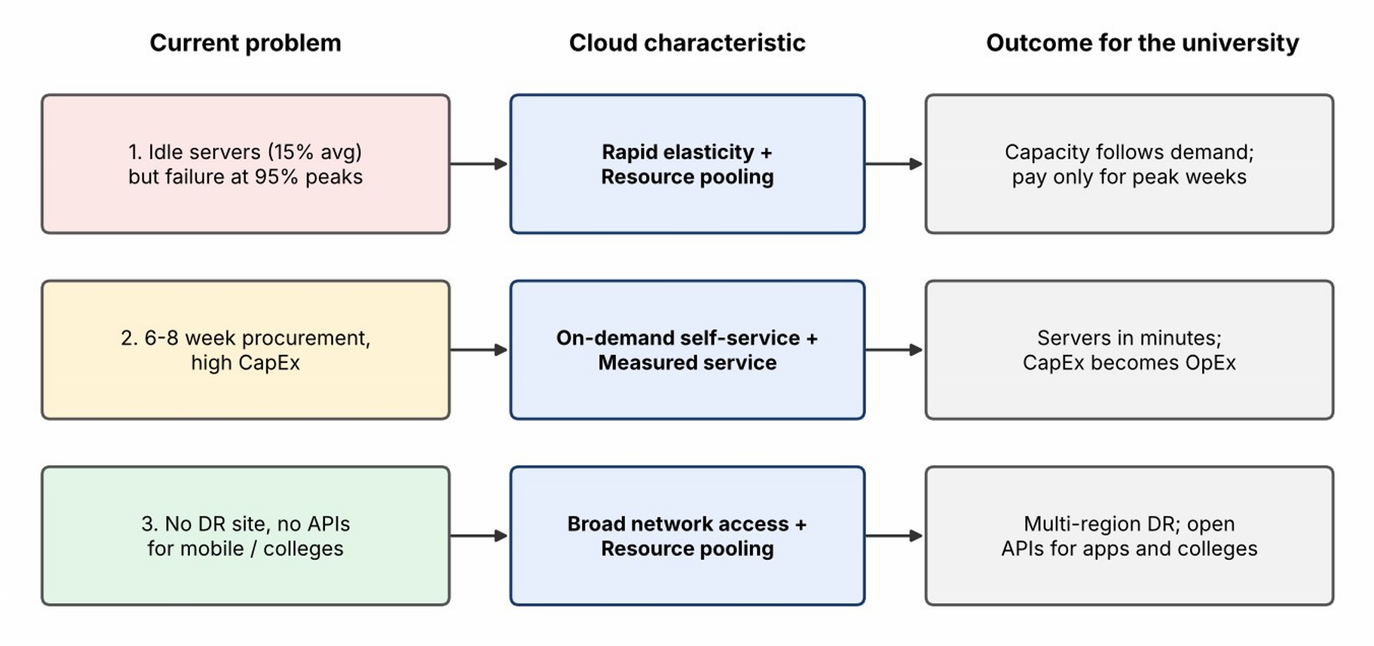
Figure 1: Current problems mapped to cloud characteristics and outcomes
Table 2: Mapping of on-premise problems to cloud characteristics
Current problem | Evidence in the scenario | Cloud characteristic that addresses it and how
1. Wasted capacity and  failure at peak | 12 servers average 15% CPU but exceed 95% during admissions and exams. | Rapid elasticity + resource pooling: instances are added automatically at peak and removed afterwards, and idle capacity is shared with other tenants rather than owned.
2. Slow, capitalheavy procurement | 6-8 weeks per server; high CapEx. | On-demand self-service + measured service: a server is created in minutes and billed by usage, converting CapEx to OpEx.
3. No disaster recovery and no public interfaces | No DR site; monoliths with no APIs for mobile apps or partner colleges. | Broad network access + resource pooling: the provider's multi-zone and multi-region infrastructure makes DR affordable, and standard networkaccessible APIs open services to mobile apps and colleges.

1.4 Benefits and limitations for the university
Benefits
- Pay-per-use economics: the university stops paying for idle servers for most of the year.
- Scalability for admissions, result publication and online-exam weeks.
- Built-in availability options (multi-zone, backups, DR region) that the university could not afford to build alone.
- Faster delivery: new services in days rather than 6-8 weeks of procurement.
- Less routine infrastructure administration, freeing staff for academic IT. Limitations
- Vendor lock-in if proprietary services are used without an exit plan.
- Data privacy and regulatory duties for the records of about 27,000 people (students and staff) remain the university's responsibility, even though the provider hosts the data.
- Dependence on internet connectivity at the four campuses; connectivity redundancy becomes essential.
- Skills gap: staff must learn cloud operations, security and cost management; uncontrolled usage can also cause bill shock.
- Legacy monolithic applications may need rework to benefit fully from the cloud.

Task 2 - Trace the Evolution and Hardware Evolution

2.1 Timeline of computing infrastructure
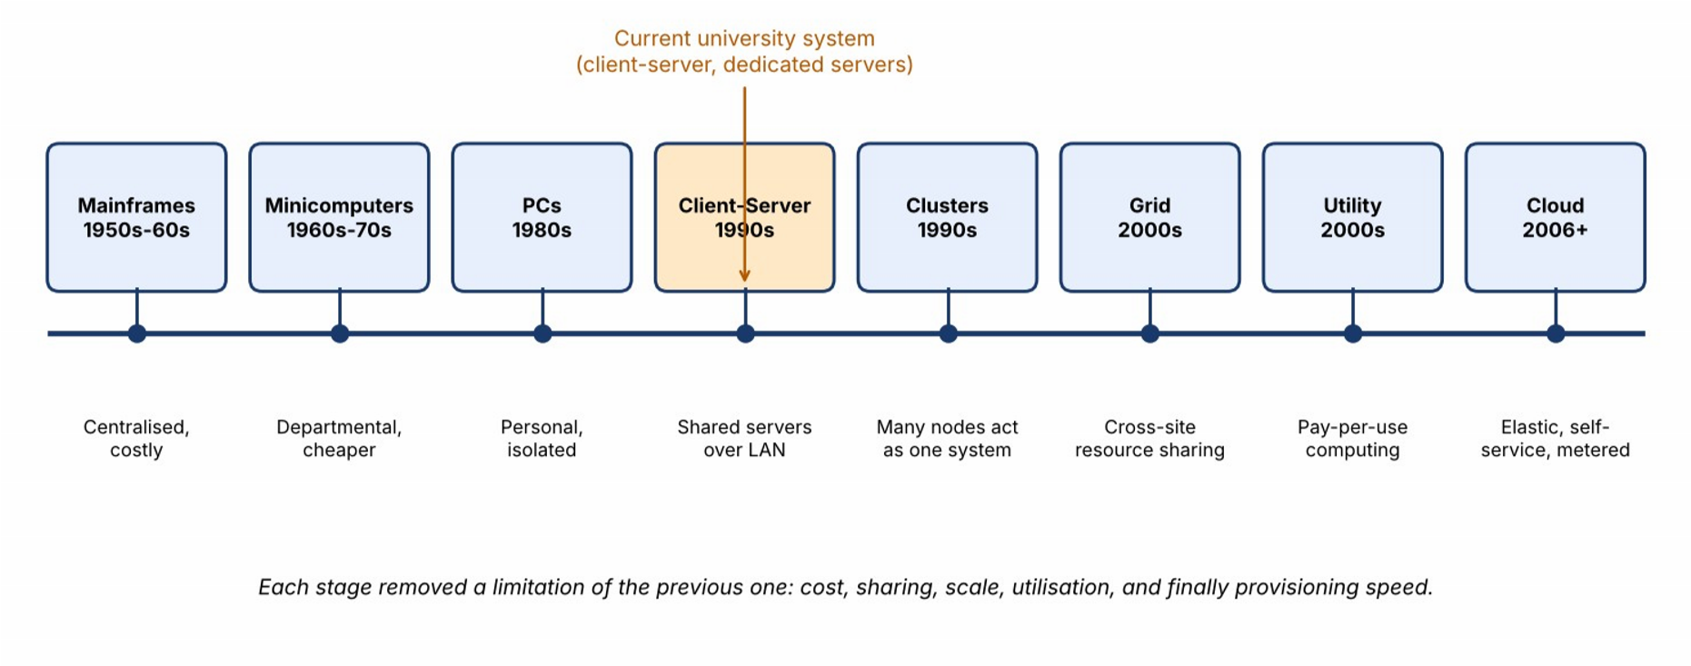
Figure 2: Evolution of computing infrastructure from mainframes to cloud, with the university's current stage highlighted
Table 3: Each stage and the limitation of its predecessor that it solved
Stage | Key idea | Limitation of the previous stage it  solved | New limitation it introduced
Mainframes (1950s-60s) | Large centralised computers with  terminals | Manual, unshared computing | Extremely costly; one site; hard to  scale
Minicomputers (1960s-70s) | Smaller departmental machines | Mainframe cost and access queues | Islands of computing; poor sharing
Personal computers (1980s) | Computing on every desk | Dependence on shared machines | Data scattered; weak collaboration and management
Client-server (1990s) | Shared servers accessed over a  LAN | Isolated PCs and duplicated data | One server per application; low utilisation; capital cost
Clusters (1990s) | Many commodity nodes working as one system | Single-server capacity and failure | Tightly coupled and managed per site
Stage | Key idea | Limitation of the previous stage it  solved | New limitation it introduced
Grid computing (2000s) | Sharing resources across organisations and sites | Cluster limits to one site | Complex middleware; limited commercial model
Utility  computing (2000s) | Metered, pay-peruse computing as a service | Fixed upfront purchase | Needed mature virtualization and automation to  deliver
Cloud computing (2006 onwards) | Elastic, selfservice, metered shared resources over the internet | Slow provisioning, idle capacity, high CapEx | Lock-in, privacy and connectivity concerns

2.2 Hardware evolution that enabled the cloud
Table 4: Hardware advances and their contribution to cloud computing
Advance | What changed | Relevance to the university's cloud
Multi-core processors | Many cores per chip instead of faster single cores | One host can run many VMs/containers, so the university's 12 servers can be consolidated onto a few hosts (Task 4).
Commodity servers | Low-cost standard x86 servers replaced proprietary systems | Providers can build huge pools cheaply and pass the savings on as pay-per-use pricing.
High-capacity storage | Large disks, SSDs and distributed object storage | Affordable storage for 27,000 users' records, LMS content and exam media, with replication and backup.
High-speed networking | Gigabit and 10/100 Gb links, fibre backbones, wide broadband | Makes remote use of applications practical from all four campuses and from mobile devices.
Data centres | Purpose-built facilities with redundant power, cooling and automation | Economies of scale and multi-zone/regional redundancy that a single campus data centre cannot match.
Advance | What changed | Relevance to the university's cloud
Hardware  virtualization support | CPU extensions (Intel VTx, AMD-V) accelerate  hypervisors | Near-native VM performance, which makes safe multi-tenancy and quick provisioning feasible.

2.3 Where the university's current system sits
The university's environment corresponds to the client-server stage with one dedicated physical server per application, running in a single on-premise data centre. The reasons are:
- Each of the five applications has its own dedicated server, which is the classic clientserver pattern before virtualization.
- Capacity is bought for the peak and sits idle (15% average utilisation), the main inefficiency that clusters, virtualization and cloud later addressed.
- There is no resource pooling, no self-service provisioning (6-8 weeks per server) and no metering, so none of the cloud characteristics are present.
- Applications are monoliths without public interfaces, which predates service-oriented design (Task 3).

Task 3 - Analyse Internet Software Evolution

3.1 From static pages to cloud-hosted applications
Table 5: Stages in the evolution of internet software
Stage | Characteristics | Contribution to cloud services
Static web  (Web 1.0) | Fixed HTML pages served over HTTP; read-only | Established HTTP and the browser as a universal client.
Dynamic web | Server-side scripts (CGI, PHP, Java servlets) and databases generate pages per request | Made web-based business applications such as fee portals possible.
Web 2.0 | User-generated content, rich interfaces, AJAX for partial page updates without reloads | Responsive browser applications that rival desktop software.
SOA and web services | Loosely coupled services with published contracts  (SOAP/WSDL, then REST) | Applications became reusable building blocks callable by other systems.
Mashups and APIs | Combining data and functions from several services into new  applications | Established the API as the unit of integration, which the mobile app and partner colleges will use.
Cloud-hosted applications | Applications delivered as services, scaled and billed by the provider | Software-as-a-Service and platforms that host applications without owned servers.

3 .2 Role of browsers, HTTP, AJAX and APIs
- Browsers act as a universal, install-free client: students on any device reach the SIS or LMS without installing software.
- HTTP/HTTPS is the standard request-response protocol that works through firewalls and, with TLS, secures data in transit.
- AJAX lets a page fetch data in the background, so a result or fee-status screen updates without a full reload, reducing server load and improving experience.
- APIs expose application functions as callable services (typically REST/JSON), so mobile apps, partner colleges and other systems can integrate without screen-scraping.

3.3 Desktop vs client-server vs web-delivered software Table 6: Comparison of software delivery models
Aspect | Desktop software | Client-server software | Web-delivered software
Installation | On every machine | Client installed; server managed centrally | None; runs in a browser
Updates | Manual on each device | Client updates required | Instant, deployed once on the server
Data location | Local files | Central server | Central, in the cloud
Scalability | Not applicable | Limited by the server bought | Scales by adding instances
Access | That device only | Mostly inside the campus network | Anywhere with internet access
Integration | Weak, file-based | Proprietary protocols | Open APIs  ( HTTP/JSON, SOAP )

3.4 Effect on the design of the university's applications
- Decompose the monoliths: break SIS, LMS and the other applications into modules that expose functions through APIs (result lookup, fee payment, library search), starting with the highest-value functions.
- Make the web tier stateless: keep session state in a cache or database so any instance can serve any request; this is what allows automatic scaling during exam weeks.
- Separate presentation from logic: one set of APIs serves the web portal, the mobile app and partner colleges.
- Secure every interface: with public APIs, authentication (OAuth2/JWT), TLS and rate limiting become part of the application design rather than an afterthought.

Task 4 - Apply Server Virtualization

4.1 How a hypervisor works
Figure below contrasts the three approaches discussed in this task.
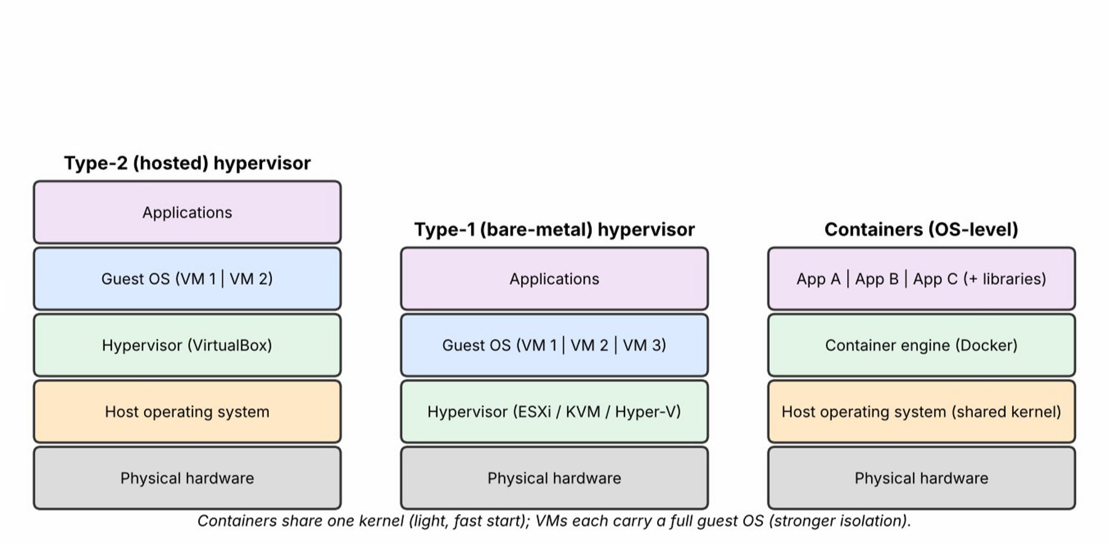
Figure 3: Type-2 hypervisor, Type-1 hypervisor and container stacks compared
A hypervisor (virtual machine monitor) is software that sits between physical hardware and operating systems. It divides a host's CPU, memory, storage and network into isolated virtual machines (VMs), each with its own guest operating system that believes it has dedicated hardware. The hypervisor schedules the VMs' CPU time, maps virtual memory to physical memory, mediates device access, and enforces isolation, so one VM cannot read or crash another.
Table 7: Type-1 and Type-2 hypervisors
Aspect | Type-1 (bare-metal) | Type-2 (hosted)
Runs on | Directly on hardware | As an application on a host operating system
Performance | Near-native; low overhead | Lower, because of the extra host OS layer
Typical use | Data centres and cloud providers | Desktops, development and testing
Examples | VMware ESXi, Microsoft HyperV, Xen, KVM | Oracle VirtualBox, VMware Workstation
Suitability here | Used for production consolidation | Used only for the proof-of-concept and student labs

4.2 Virtualization techniques compared
Table 8: Full, para-, OS-level and hardware-assisted virtualization
Technique | How it works | Strengths | Weaknesses
Full virtualization | Hypervisor emulates complete hardware; the guest OS is unmodified | Runs any OS; strong isolation | Emulation overhead without hardware assistance
Paravirtualization | Guest OS is modified to make hypercalls to the hypervisor | Lower overhead than softwareemulated full  virtualization | Needs a modified guest OS; limited  OS choice
OS-level (containers) | Containers share the host kernel with isolated processes and file systems | Very lightweight; starts in seconds;  high density | Same kernel for all; weaker isolation than VMs;  Linux/Windows kernel limits
Hardwareassisted | CPU extensions (VT-x,  AMD-V) let the hypervisor run guests  directly | Near-native speed with unmodified guests | Requires supporting CPUs; not a separate model, as it underpins modern  full virtualization

4.3 Which applications run as VMs and which as containers
Table 9: Virtualization choice per application (current 12-server split assumed)
Application ( servers ) | Component |  | Choice | Reason
SIS (3) | Monolithic application and database |  | VM | Legacy monolith with OS dependencies; stateful database needs strong isolation and snapshots.
LMS (3) | Web/application tier |  | Container | Stateless web tier that scales out quickly for exam weeks.
LMS (3) | Database |  | VM (later DBaaS) | Stateful; safer in a VM, then moved to a managed database.
Exam Portal  (3) | Web and API tier |  | Container | Highly bursty; containers start in seconds and pack densely.
Application ( servers ) | Component |  | Choice | Reason
Library (1) | Catalogue application | web | Container | Small and stateless; low resource need.
Email (2) | Mail servers |  | VM | Stateful, long-running, securitysensitive; strong isolation preferred (later replaced by SaaS).

4.4 Consolidation calculation
Assumptions: 12 identical physical servers; each averages 15% CPU utilisation; each new host has the same capacity as one old server (a conservative assumption, since modern hosts are normally more powerful); target host utilisation is 70% to leave headroom; hypervisor overhead is 10%; CPU is the limiting resource.

Step 1 - Total average workload
Total load = number of servers x average utilisation
= 12 x 15% = 12 x 0.15 = 1.8 server-equivalents (SE)

Step 2 - Hosts needed at the 70% target (no overhead)
Hosts = total load / target utilisation
= 1.8 / 0.70 = 2.57 -> round up to 3 hosts

Step 3 - Allow for hypervisor overhead (10%)
Load with overhead = 1.8 x 1.10 = 1.98 SE
Hosts = 1.98 / 0.70 = 2.83 -> 3 hosts

Step 4 - Add fault tolerance (N+1)
Production hosts = 3 + 1 spare for failover/maintenance = 4 hosts
Consolidation ratio = 12 servers : 4 hosts = 3 : 1
Hardware reduction = (12 - 4) / 12 = 66.7%

Step 5 - Peak-load check (the caution)
Worst case, every server at 95% together:
12 x 0.95 = 11.4 SE -> 11.4 / 0.70 = 16.3 -> 17 hosts

Realistic case, only SIS, LMS and Exam Portal (9 servers) peak:
(9 x 0.95) + (3 x 0.15) = 8.55 + 0.45 = 9.0 SE -> 9.0 / 0.70 = 12.9 -> 13 hosts Interpretation: for average load, 3 hosts are enough, and 4 with an N+1 spare give a 3:1 consolidation. However, the average-load answer must not be used for peak weeks: a fixed pool sized for the peak would need 13 to 17 hosts and would sit idle for most of the year, which is exactly today's problem. Therefore the baseline is virtualized on about 4 hosts' worth of capacity, and peak demand is met by elastic cloud scaling (Task 8). The result also needs validation by load testing, since CPU is not the only constraint (memory, storage I/O and network can limit first).

4.5 Benefits and risks of virtualization Table 10: Benefits and risks of virtualization
Feature / risk | Explanation | Relevance to the university
Live migration  (benefit) | A running VM moves to another host without downtime. | Hosts can be patched during working hours without taking SIS or Email offline.
Snapshots (benefit) | Point-in-time state of a VM that can be restored. | Quick rollback before upgrades to SIS or before result publication.
Overcommitment  (benefit) | Allocating more virtual CPU/RAM than physically present, since VMs rarely peak together. | Lifts density, but must be limited (for example CPU 2:1, memory about 1.2:1) to avoid peak contention.
Noisy neighbour  (risk) | One busy VM consumes shared resources and slows others. | Exam Portal peaks could slow Email; use resource limits, reservations and separate pools.
Hypervisor failure (risk) | A host or hypervisor fault takes down every VM on it. | Mitigate with clustering, N+1 hosts, automatic restart and multi-zone placement.
Security isolation (risk) | A flaw could let one VM or container reach another or the hypervisor. | Keep the hypervisor patched, separate sensitive systems, restrict container privileges and segment networks.

Task 5 - Apply Web Services

5.1 Web services in cloud and SOA
A web service is a software function exposed over a network using standard protocols so that other programs can call it regardless of language or platform. In a service-oriented architecture (SOA) an application is built from such services with published contracts; in the cloud they are the way the mobile app, partner colleges and other systems reach the university's functions without direct database access. This is why APIs become critical once the university opens its services (Task 11).

5.2 SOAP, WSDL, UDDI and REST compared
Table 11: SOAP-based services versus RESTful services
Aspect |  | SOAP / WSDL / UDDI | REST
Nature |  | Protocol with a strict XML envelope | Architectural style over plain  HTTP
Contract |  | WSDL describes operations and message formats formally | Informal, often described with OpenAPI
Discovery |  | UDDI registry for publishing and finding services (rarely used today) | Documented endpoints; API catalogue/gateway
Message format |  | XML only | JSON (most common), XML or others
HTTP methods |  | Typically POST only | GET, POST, PUT, PATCH,  DELETE map to  read/create/update/delete
Security |  | WS-Security (message-level, signing, encryption) | TLS plus OAuth2/JWT at transport and token level
Weight speed | / | Heavier; more parsing overhead | Lightweight; cacheable; ideal for mobile
Best when |  | Formal contracts, message-level security, enterprise/bank  integration | Public, mobile and web-facing APIs

5.3 University functions exposed as web services
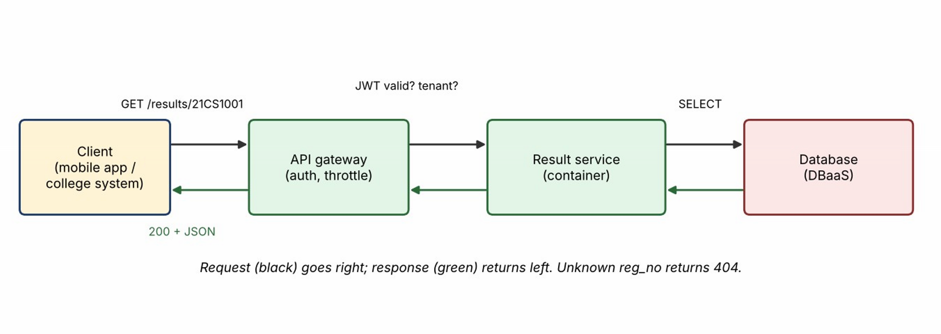
Figure 4: Request and response flow for the result-lookup web service
Table 12: Three university web services
Function | Endpoint | Method | Style
Result lookup | /api/v1/results/{regNo} | GET | REST
Fee payment | /api/v1/fees/payments | POST | REST (with a SOAP adapter for the legacy bank gateway)
Library search | /api/v1/library/books?title={text} | GET | REST
Service 1 - Result lookup
Request: GET /api/v1/results/21CS1001
Authorization: Bearer <token>

Response: HTTP 200 OK
{ "reg_no": "21CS1001", "name": "Asha R", "semester": 5, "sgpa": 8.7 }

Not found: HTTP 404 Not Found
{ "error": "Result not found", "reg_no": "99XX0000" }
Why REST: a read-only, high-volume, cacheable lookup. REST with JSON is light, works naturally with the mobile app, and results can be cached at the CDN and in-memory cache to absorb result-publication spikes.
Service 2 - Fee payment
Request: POST /api/v1/fees/payments
Authorization: Bearer <token>
Idempotency-Key: 7f3c-2b9a-41e0
{ "reg_no": "21CS1001", "term": "2026-ODD", "amount": 45000, "currency": "INR", "method": "UPI" }

Response: HTTP 201 Created
{ "payment_id": "PAY-884201", "status": "PENDING",
"redirect_url": "https://pay.example.edu/checkout/PAY-884201" }
Why REST (with a SOAP adapter where needed): the mobile app and affiliated colleges need a lightweight, mobile-friendly interface, so the public API is REST over TLS with OAuth2 tokens and an idempotency key to prevent double charging on retries. Some legacy bank or partner-ERP gateways still require SOAP with WS-Security and a WSDL contract; the platform therefore keeps a thin SOAP adapter behind the REST API for those back-end integrations only.
< soapenv:Envelope xmlns:soapenv="http://schemas.xmlsoap.org/soap/envelope/" >
<soapenv:Body>
<ChargeRequest>
<RegNo>21CS1001</RegNo><Amount>45000</Amount><Currency>INR</Currency >
</ChargeRequest>
</soapenv:Body>
< /soapenv:Envelope >
Service 3 - Library search
Request: GET /api/v1/library/books?title=cloud

Response: HTTP 200 OK
{ "count": 2, "items": [
{ "isbn": "9780000000001", "title": "Cloud Computing Essentials", "available": 3 },
{ "isbn": "9780000000002", "title": "Cloud Architecture Patterns", "available": 0 } ] }
Why REST: a public, read-only, cacheable search that benefits from JSON, query parameters and HTTP caching. SOAP's strict envelope would add overhead with no benefit.
The sample values in Services 2 and 3 are illustrative design examples. Only the resultlookup service is implemented in the proof-of-concept (Task 9).

Task 6 - Analyse the Service Models: IaaS, PaaS and SaaS

6.1 Definitions and layer-wise responsibility
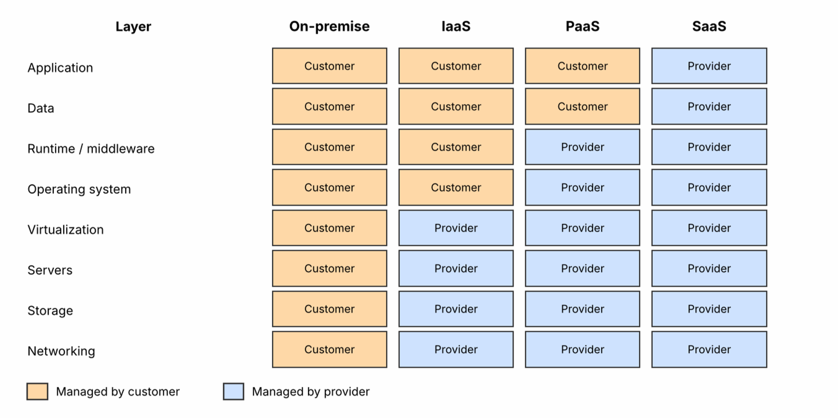
Figure 5: Who manages each layer in on-premise, IaaS, PaaS and SaaS
- IaaS (Infrastructure as a Service): the provider supplies virtualized compute, storage and networking; the customer manages the operating system and everything above.
- PaaS (Platform as a Service): the provider also manages the OS, runtime and middleware; the customer deploys and manages the application and data.
- SaaS (Software as a Service): the provider runs the complete application; the customer only configures it and manages users and content.
Table 13: Who manages which layer (C = customer, P = provider)
Layer | Onpremise | IaaS | PaaS | SaaS
Application | C | C | C | P
Data | C | C | C | P (customer owns content)
Runtime / middleware | C | C | P | P
Operating system | C | C | P | P
Virtualization | C | P | P | P
Servers | C | P | P | P
Storage | C | P | P | P
Networking / data centre | C | P | P | P

6.2 Categorising the five applications
Table 14: Mapping of university applications to service models
Application | Model | Provider example | Reason
Student Information  System (SIS) | IaaS | AWS EC2, Azure Virtual Machines | Custom monolith with OS-level dependencies; needs a lift-and-shift into VMs with full control and cannot be rewritten quickly.
Learning Management  System (LMS) | PaaS | Azure App  Service, AWS  Elastic Beanstalk | A web application (for example Moodle-type) that can run on a managed runtime and database, scaling for exam weeks without OS management.
Exam Portal | PaaS | Google App  Engine / Cloud  Run | Extremely bursty; autoscaling containers on a managed platform match the peaks and avoid idle cost.
Library System | SaaS | Hosted library system (for example hosted  Koha) | Commodity function with standard features; a hosted product removes all administration.
Email | SaaS | Google Workspace for Education, Microsoft 365  Education | Mature commodity service; building and securing it internally brings no advantage.
Reasoning behind each decision. The mapping follows a simple rule: the more standard the function, the higher up the stack it should be bought; the more custom and legacy the function, the lower it must be placed.
- SIS to IaaS. The SIS is the university's most customised and most critical system. Its monolithic code ties it to a specific operating system and database configuration. Rewriting for a platform would take longer than the migration window and risk student records, so it is rehosted on VMs (full control, easy snapshots) and modernised gradually behind an API layer.
- LMS to PaaS. An LMS is a standard web-and-database application. Running it on a managed platform gives automatic scaling and patching while allowing the university to keep its own plug-ins and data. A full SaaS LMS was rejected for now because course content and integrations with the SIS need control that a shared SaaS may restrict.
- Exam Portal to PaaS. The workload is concentrated into a few exam weeks. PaaS autoscaling lets the portal grow within minutes and shrink afterwards, which IaaS would need manual or scripted work to match, and SaaS would not allow the university's custom exam rules.
- Library to SaaS. Library cataloguing and lending are well-standardised, low-risk and low-volume. A hosted service removes administration with negligible loss of control.
- Email to SaaS. Running mail servers is labour-intensive and security-sensitive (spam, phishing, deliverability). Education SaaS suites provide it at low cost with high availability.

6.3 Comparing the models
Table 15: IaaS, PaaS and SaaS compared
Criterion | IaaS | PaaS | SaaS
Control | Highest: OS, runtime and application | Medium: application and data | Lowest: configuration only
Cost model | Pay for VMs/storage; low unit price but more staff | Pay for platform usage; moderate | Per-user subscription; predictable, may rise with users
Scalability | Manual or scripted scaling | Automatic scaling built in | Handled entirely by the provider
Maintenance effort | High: patching, backup, tuning | Medium: application only | Minimal
Vendor lockin | Lowest (VMs are portable) | Medium (platformspecific services) | Highest (data export and workflow  dependence)
Typical provider | AWS EC2, Azure  VMs, Google  Compute Engine | Azure App Service,  Google App Engine,  Heroku | Google Workspace,  Microsoft 365,  Salesforce

Task 7 - Examine XaaS

7.1 What is XaaS
XaaS (Anything-as-a-Service) is the broad idea that almost any IT capability can be consumed as a metered, provider-operated service, extending beyond IaaS, PaaS and SaaS. The customer specifies what it needs and the provider handles how it is delivered, scaled and maintained.

7.2 Six XaaS variants
Table 16: XaaS variants and university relevance
Variant | What it provides | University relevance
DaaS - Desktop as a Service | Hosted virtual desktops streamed to any device | Computer-lab desktops and remote access to licensed software for students.
MBaaS / BaaS -  (Mobile) Backend as a Service | Ready-made backend: authentication, push notifications, data sync, storage | Speeds up the new mobile app launched on Day 4.
FaaS - Function as a Service (serverless) | Event-triggered code run and billed per execution | Result-published notifications, receipt generation, file processing.
DBaaS - Database as a Service | Managed database with backup, patching, replication and failover | Records of 27,000+ users with minimal database administration.
SECaaS - Security as a Service | Managed WAF, identity, threat detection | Protection for public APIs and student data.
DRaaS - Disaster  Recovery as a  Service | Replicated environment in another region with managed failover | Fills the university's complete lack of a DR site.

7 .3 Two selected offerings and why

Selection 1 - DBaaS
- The student, fee and result data are the university's most valuable and most sensitive assets, and the databases are currently tied to ageing servers.
- Managed multi-zone replication, automated backups, point-in-time recovery and patching remove a major administrative burden and a key single point of failure.
- It supports read replicas for the read-heavy result-publication peaks.

Selection 2 - DRaaS
- The university has no DR site today, so a single data-centre failure would stop every service.
- Building a second physical data centre would cost tens of lakhs (Task 10); DRaaS replicates to another region and charges mainly for storage until a failover is needed.
- It gives a defined recovery target (for example RPO about 15 minutes and RTO about 4 hours in the base design), which can be tightened later.

7.4 Risks of over-reliance on many as-a-Service providers
- Vendor lock-in and exit cost: proprietary services and data formats make switching expensive.
- Cascading dependencies: an outage at a single provider (identity, DNS, payment) can take down several university services at once.
- Integration and security complexity: every provider adds credentials, APIs and a separate security boundary.
- Cost sprawl: many small subscriptions are hard to track and can exceed budget; chargeback and tagging are needed.
- Compliance and visibility: data may move through several vendors and jurisdictions with different terms.
- Mitigation: limit the number of providers, keep data exportable, use open standards ( SQL, containers, OpenAPI), review SLAs, and rehearse failure and exit scenarios.

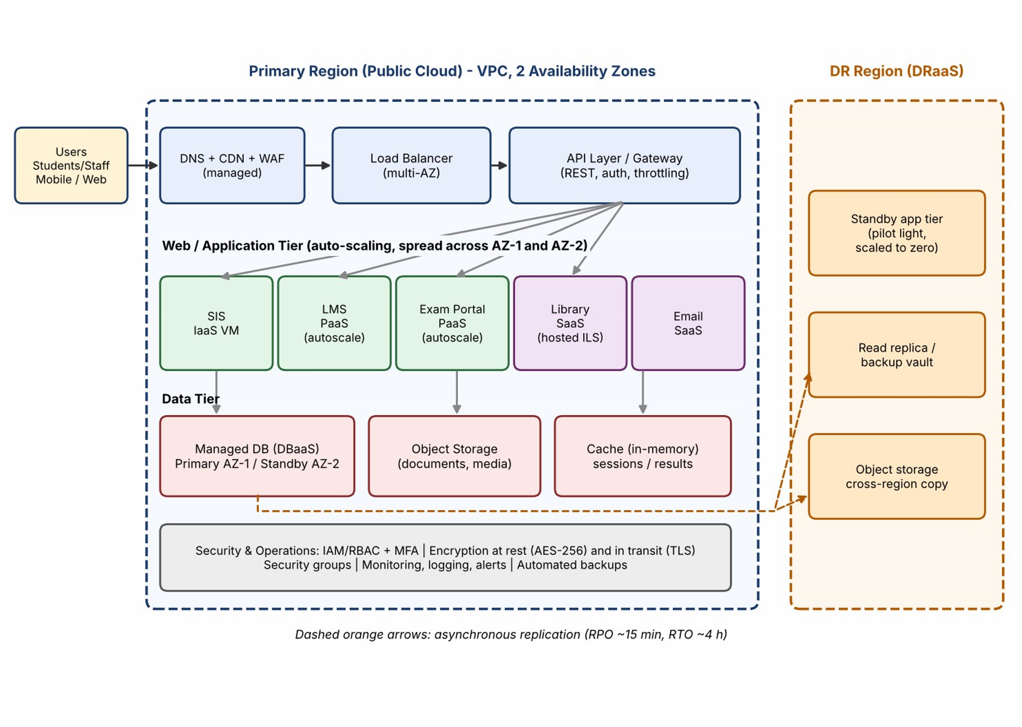
8.1 Component justification and chosen models
Task 8 - Design the Cloud Solution Architecture
Figure 6:
Proposed cloud architecture for the university (baseline design)
Table 17: Components, deployment model and service model
Component | Deployment / service model | Justification
Users, DNS, CDN, WAF | Public cloud edge / SaaS-managed | Global edge caching offloads static content and result pages; WAF blocks common web attacks.
Load balancer | Public cloud / IaaSlevel managed service | Spreads requests across instances in two availability zones; removes single point of failure.
API layer / gateway | Public cloud / PaaS | Single controlled entry point with authentication, throttling and versioning for web, mobile and partner use.
SIS | IaaS VM (multi-AZ pair) | Lift-and-shift of the monolith with full control, behind the API layer.
Component | Deployment / service model | Justification
LMS and Exam  Portal | PaaS with autoscaling | Managed runtime scales out in minutes for admissions and exams.
Library and  Email | SaaS | Commodity functions with zero infrastructure administration.
Relational database | DBaaS, multi-AZ with standby | Automatic failover, backups and patching for critical records.
Object storage | Public cloud storage service | Durable, cheap storage for documents and exam media with versioning.
Cache (inmemory) | Managed cache service | Serves repeated result and session reads, protecting the database during peaks.
DR region | DRaaS / warm standby in another region | Cross-region replicas and backups provide recovery from a regional failure.

8.2 How elasticity handles admissions and exam peaks
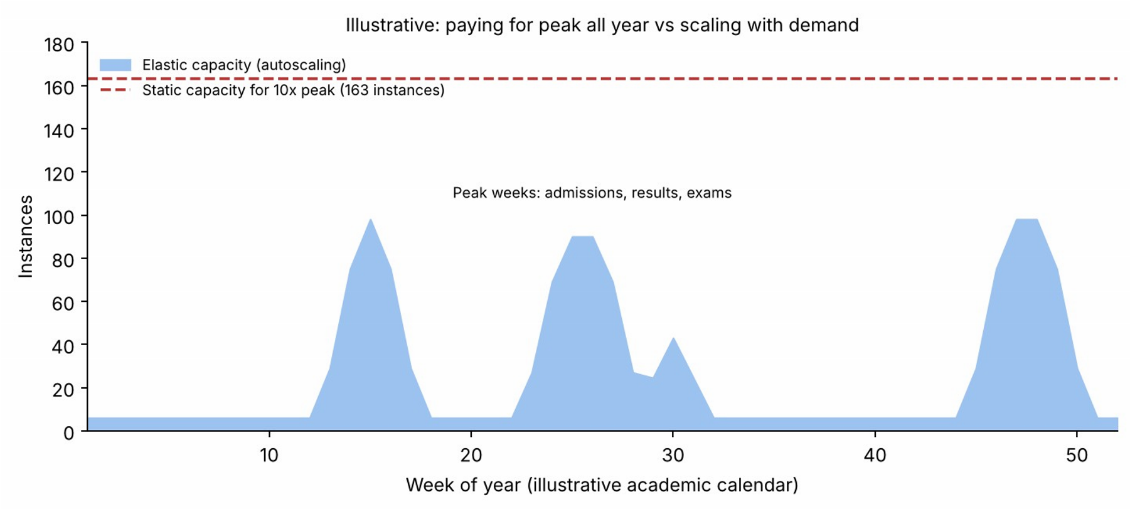
Figure 7: Elastic capacity versus static peak capacity over a year (illustrative)
- Scheduled scaling: before known events (admission week, result publication, online exams) capacity is increased in advance, since load patterns are predictable.
- Metric-based autoscaling: the PaaS/VM groups add instances when average CPU exceeds about 60-70% or request latency rises, and remove them when load falls.
- Stateless web tier + cache: because sessions live outside the instances, any new instance can serve users immediately.
- Cost effect: the university pays for peak capacity only for the weeks it is needed, instead of owning it all year.

8.3 Security and availability measures
- Access control: role-based access (RBAC) and least privilege; multi-factor authentication for staff and administrators.
- Encryption: TLS for data in transit; AES-256 encryption at rest with managed keys for databases and storage.
- Network protection: private subnets for the database, security groups, WAF and DDoS protection at the edge.
- Backup and recovery: automated daily backups plus point-in-time recovery; periodic restore tests.
- Multi-zone deployment: application and database spread across two availability zones; cross-region replication to the DR region.
- Monitoring: centralised logging, alerts and audit trails for security and capacity events.
Sizing in this baseline design is based on stated assumptions (Task 4) and must be confirmed by load testing before go-live.

Task 9 - Hands-on Implementation and Documentation

Evidence status: the code in this section was written and tested for this report. The Flask API was run locally and returned the HTTP 200 and 404 responses shown below. The Docker build and the cloud (PaaS) deployment were NOT executed while preparing this report. Run each step yourself, and insert your own screenshots in the orange boxes. Do not submit placeholders as evidence.

9.1 Proof-of-concept scope
The proof-of-concept implements the result-lookup web service (Task 5, Service 1) as a small Python Flask REST API. It is packaged as a Docker container (virtualization, Task 4) and then deployed to a managed PaaS or serverless host (Task 6/7). A client (curl, browser or Postman) tests a success case (HTTP 200) and a failure case (HTTP 404). Table 18: Environment and tools
Item | Value (replace with your own versions)
Operating system | Windows 11 / Ubuntu 22.04 (fill in)
Python | 3.12 ( run: python --version )
Docker | Docker Desktop (run: docker --version)
Libraries | flask 3.0.3, gunicorn 22.0.0
Test client | curl / Postman / browser
PaaS target (choose one) | Render, Azure App Service (free tier), Google Cloud Run, or a static site / serverless function

9 .2 Source code app.py
from flask import Flask, jsonify

app = Flask(__name__)

RESULTS = {
"21CS1001": {"name": "Asha R", "semester": 5, "sgpa": 8.7},
"21CS1002": {"name": "Karthik M", "semester": 5, "sgpa": 7.9}, }

@app.route("/") def home():
return jsonify(service="Smart Campus Result API", status="running")

@app.route("/api/v1/results/<reg_no>", methods=["GET"]) def get_result(reg_no):
rec = RESULTS.get(reg_no)
if rec is None:
return jsonify(error="Result not found", reg_no=reg_no), 404 return jsonify(reg_no=reg_no, **rec), 200

if __name__ == "__main__":
app.run(host="0.0.0.0", port=5000)

requirements.txt
flask==3.0.3 gunicorn==22.0.0

Dockerfile
FROM python:3.12-slim WORKDIR /app
COPY requirements.txt .
RUN pip install --no-cache-dir -r requirements.txt
COPY app.py .
EXPOSE 5000
CMD ["gunicorn", "-b", "0.0.0.0:5000", "app:app"]

9.3 Step A - Run locally and test
mkdir smartcampus-api && cd smartcampus-api # place the three files here python -m venv venv
venv\Scripts\activate # Windows (Linux/macOS: source venv/bin/activate)
pip install -r requirements.txt
python app.py
In a second terminal run the success and failure tests:
curl -i http://localhost:5000/api/v1/results/21CS1001
curl -i http://localhost:5000/api/v1/results/99XX0000
Table 19: Test cases and the output observed when this code was run locally while preparing the report
Test | Request | Expected / observed result
Functiona l  (success) | GET  /api/v1/results/21CS100  1 | HTTP/1.1 200 OK  {"name":"Asha  R","reg_no":"21CS1001","semester":5,"sgpa ":8.  7}
Failure case | GET  /api/v1/results/99XX000  0 | HTTP/1.1 404 NOT FOUND  {"error":"Result found","reg_no":"99XX0000"} | not
[ INSERT YOUR OWN SCREENSHOT HERE ]
Terminal showing 'python app.py' running and both curl commands with their responses ( include the date/time or your username in the frame ).
Figure 8: Local run of the Flask server and curl tests showing HTTP 200 and 404

9.4 Step B - Containerize (virtualization evidence )
docker build -t smartcampus-api:1.0 .
docker run -d --name sc-api -p 5000:5000 smartcampus-api:1.0 docker ps curl -i http://localhost:5000/api/v1/results/21CS1001 curl -i http://localhost:5000/api/v1/results/99XX0000 docker logs sc-api
[ INSERT YOUR OWN SCREENSHOT HERE ]
Output of 'docker build', 'docker ps' (container Up, port 5000) and the curl tests against the container.
Figure 9: Docker image built and container running

9.5 Step C - Deploy to a PaaS or serverless service
Choose one free-tier option and record the exact steps you took. An example using a container-capable PaaS:
- Push the three files to a new GitHub repository.
- In the PaaS dashboard, create a new Web Service from that repository, selecting the Dockerfile build (or Python runtime with start command 'gunicorn -b 0.0.0.0:$PORT app:app').
- Choose the free instance type, set the region closest to your campus, and deploy.
- When the deployment shows 'Live', open the public URL and test both cases.
curl -i https://<your-service-name>.<provider-domain>/api/v1/results/21CS1001
curl -i https://<your-service-name>.<provider-domain>/api/v1/results/99XX0000
Platform note: some PaaS hosts supply the listening port in a PORT environment variable. If your host does so, change the gunicorn command to bind to that port instead of 5000.
[ INSERT YOUR OWN SCREENSHOT HERE ]
PaaS dashboard (service status 'Live/Running', region and public URL visible).
Figure 10: Cloud deployment dashboard showing the service as live
[ INSERT YOUR OWN SCREENSHOT HERE ]
curl or Postman calls to the public URL showing 200 and 404 responses.
Figure 11: Test of the deployed web service from a client

9.6 Issues faced and fixes
Record the real problems you meet while running the steps. The table below lists issues that commonly occur with this setup as a guide; keep only those that happened to you and add any others.
Table 20: Issue log (edit to match your own run)
Possible issue | Typical cause | Fix
'Port already in use' on 5000 | Another process (for example macOS AirPlay) is using the port | Stop the process or map a different host port: -p 5001:5000
Container runs but curl fails | App bound to 127.0.0.1 inside the container | Bind to 0.0.0.0 (done in app.py and the gunicorn command)
Docker build cannot reach the package index | Network or proxy restrictions on campus | Use another network or configure the Docker proxy settings
PaaS shows 'deploy failed' | Start command or port mismatch | Check the service logs; bind to the port the platform provides
Free-tier service is slow on first request | Instance sleeps when idle | Expected on free plans; retry after the cold start

9.7 Reproducibility checklist
- All source files are listed above; build and run commands are exact.
- Endpoints: GET / (health), GET /api/v1/results/{reg_no}.
- Expected results: 200 with JSON for 21CS1001 and 21CS1002; 404 with an error JSON for any other registration number.
- Production hardening that is out of scope here: authentication, a real database, input validation, rate limiting and HTTPS (provided by the PaaS).

Task 10 - Evaluate and Recommend the Final Solution

10.1 Comparison of the three options
Table 21: On-premise versus IaaS-based versus PaaS/SaaS-based
Criterion | A. On-premise refresh | B. IaaS-based | C. PaaS/SaaS-based  ( hybrid transition )
Cost model | High CapEx  (hardware, DR site) plus fixed OpEx | OpEx; pay for VMs even when underused | OpEx; pay per use with managed services
Scalability | Fixed; peak capacity must be bought | Good but needs scripting and admin effort | Best: built-in autoscaling
Availability | Single site; DR is a large extra cost | Multi-zone possible, self-managed | Multi-zone and managed failover by default
Security | Fully in the university's hands, but needs specialist staff | Shared responsibility; OS and apps are the  university's | Provider secures most layers; the university manages access and data
Management effort | Highest (4 admins assumed) | High (3 admins assumed) | Lowest (2 cloud engineers assumed)
Lock-in | None (but hardware is fixed) | Low | Medium (platform services)
Time to deliver | 6-8 weeks per server, DR site much longer | Weeks | Weeks; some applications need rework

10 .2 Three-year cost estimate
Stated assumptions: all figures in INR lakh; 3-year horizon; no inflation or discounting; cloud prices are representative planning rates and should be replaced with provider quotations before approval. Staff cost is taken as 8 lakh per administrator per year.
Table 22: Three-year cost comparison (INR lakh)
Cost item | A. Onpremise refresh |  | B. IaaS-based | C. PaaS/SaaSbased
Servers (12 x 6 lakh) | 72.0 |  | - | -
Cost item | A.  premise refresh | On- | B. IaaS-based | C. PaaS/SaaSbased
Storage and network equipment | 20.0 |  | - | -
DR site setup | 50.0 |  | - | -
One-time CapEx total | 142.0 |  | - | -
Migration and training (one time) | - |  | 18.0 (15 + 3) | 26.0 (22 + 4)
Power, cooling, space (per year) | 12.0 |  | - | -
Staff (per year) | 32.0 admins) | (4 | 24.0 (3 admins) | 16.0 (2 engineers )
Hardware maintenance, AMC at 10% (per year) | 9.2 |  | - | -
Compute: VMs / PaaS /  SaaS (per year) | - |  | 24.0 (18 reserved + 6 burst) | 23.0 (email 5 + PaaS 12 + SIS  VMs 6)
Database service (per year) | - |  | (self-managed on  VMs) | 9.0
Storage (per year) | - |  | 10.0 | 8.0
DR / backup (per year) | - |  | 6.0 | 4.0
Data transfer (per year) | - |  | 4.0 | 3.0
Annual running cost | 53.2 |  | 68.0 | 63.0
3-year total (= one-time + 3 x annual) | 301.6 |  | 222.0 | 215.0
Saving versus option A | - |  | 26.4% | 28.7 %
A: 142.0 + 3 x 53.2 = 142.0 + 159.6 = 301.6 B: 18.0 + 3 x 68.0 = 18.0 + 204.0 = 222.0
C: 26.0 + 3 x 63.0 = 26.0 + 189.0 = 215.0
Savings: A->B (301.6-222.0)/301.6 = 26.4% A->C (301.6-215.0)/301.6 = 28.7%
Reading the result. Both cloud options are roughly 26-29% cheaper than refreshing the onpremise data centre, and they include a DR capability that option A pays 50 lakh for up front. The difference between B and C (about 7 lakh) is small and well within the uncertainty of the assumptions, so cost alone does not decide between them; the deciding factors are management effort, built-in scaling and availability, where option C is stronger.
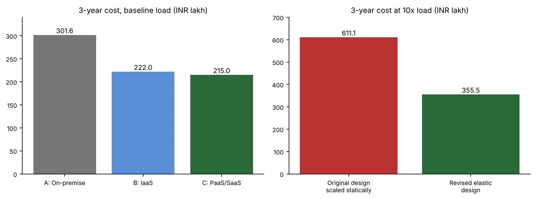
Figure 12: Three-year cost comparison: baseline options (left) and the 10x-load designs ( right )

10.3 Main risks and mitigation
Table 23: Risk register
Risk |  | Impact | Mitigation
Vendor lock-in |  | High switching cost for PaaS/SaaS services | Use containers, standard SQL and open APIs; keep regular data exports; document an exit plan; avoid proprietary services for core logic.
Data privacy and compliance |  | Breach or violation of data protection obligations for student and staff records | Choose an Indian region, encrypt at rest and in transit, enforce RBAC and MFA, sign a data-processing agreement, audit access logs.
Downtime provider outage | / | Services unavailable during admissions or exams | Multi-AZ design, DR region, tested failover, freeze windows before key events, status monitoring.
Skills gap |  | Misconfiguration, insecure setup or cost overruns | Training and certification, a small cloud centre of excellence, infrastructure-as-code reviews, managed-service partner for the first year.
Cost overrun |  | Budget exceeded through unmanaged autoscaling | Budgets and alerts, tagging, autoscaling limits, reserved capacity for baseline.
Migration failure |  | Data loss or extended outage during cut-over | Phased migration, rehearsals, backups before each step, rollback plan.

10.4 Final recommendation
Recommendation: adopt Option C - a PaaS/SaaS-first public cloud solution with IaaS only for the legacy SIS, reached through a hybrid transition. The recommendation follows from the earlier analysis: the 15% average and 95% peak utilisation (Task 4) shows that elasticity, not owned capacity, is the right answer; Task 6 shows that four of five applications can move to managed services; the DR gap is closed by DRaaS (Task 7); and the cost model above shows a 28.7% three-year saving over refreshing on-premise. No specific provider is recommended here without a quotation; the selection criteria should be Indian-region availability, published SLA of at least 99.9% for the services used, dataexport options, education pricing and support.

10.5 Migration roadmap
Table 24: Phased migration roadmap
Phase | Applications | Why in this order
0 (weeks 14) | Landing zone: accounts, network, identity, security baseline,  backups, training | Foundation and skills must exist before any application moves.
1 (weeks 58) | Email, then Library (SaaS) | Lowest risk and no custom code; delivers quick, visible savings and builds confidence.
2 (weeks 916) | Exam Portal, then LMS (PaaS) | Highest peak pain and the clearest benefit from elasticity; migrate before the next exam cycle.
3 (weeks  17-28) | SIS (IaaS rehost), database to DBaaS, APIs added | Most critical and complex; moved last, when the team is experienced, with a rehearsed cut-over and rollback.
4 (weeks  29-36) | DR region, optimisation, decommission the data centre | Complete resilience and release the capital tied up in old servers.
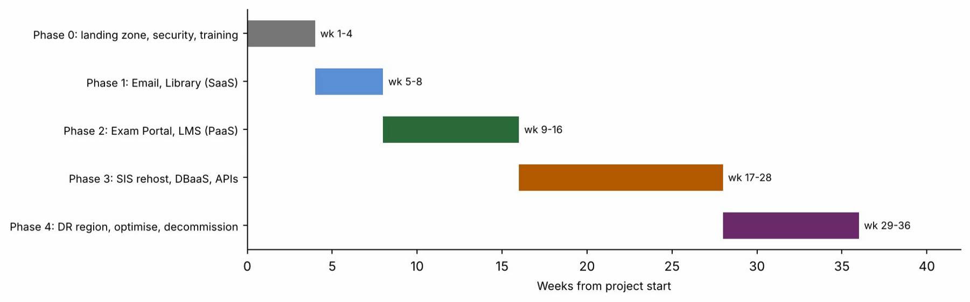
Figure 13: Phased migration timeline (36 weeks)
The Exam Portal is placed before the SIS even though the SIS is more critical, because it gains the most from elasticity and is largely stateless, so it carries a lower migration risk.

Task 11 - Day-4 Design Challenge: Re-evaluate and Adapt the Design

Decision: MODIFY. The original service-model strategy (SaaS for commodity applications, PaaS for bursty web applications, managed database, DR in another region) remains sound, but the architecture, virtualization approach and operating model must be significantly extended to meet 10x load, 99.9% availability, a mobile app and 40-college multi-tenancy within a limited budget. A full redesign is not needed.

11.1 Impact analysis
What has changed
- Users move from about 27,000 people on four campuses to those plus a mobile user base and the staff and students of 40 affiliated colleges.
- The load is 10x the current peak; the university now serves external organisations, not only its own staff and students.
- Fee payment and student records become externally visible, business-critical services with a 99.9% availability target.
Original assumptions affected
Table 25: Original assumptions versus the new situation
Assumption | Original | Now | Effect
Load | Peak equals 95% of 12 servers (11.4  SE) | 10x = 114 SE | Autoscaling range and database capacity must grow by an order of magnitude.
Users | Internal, one organisation | Multiple organisations + mobile | Identity, isolation, API throttling and abuse protection are essential.
Availability | No stated target; two zones, one  region | 99.9% (8.76 h/year) | Single points of failure and regional outages must be addressed.
Cost | Optimised for one organisation | Limited operating budget at 10x | Static capacity is unaffordable; consumption-  based design and chargeback needed.
Why web services and APIs now become critical
Before Day 4 the APIs were an enabler; now they are the product. The mobile app and each college's systems can only reach student-record and fee-payment functions through them, so the API layer must be secure, versioned, rate-limited, monitored and highly available. Every college and the app becomes an API consumer whose usage must be authenticated, metered and limited so that one consumer cannot degrade service for the rest.
Effect of multi-tenant access by 40 colleges on security and isolation
- Data isolation: each college may see only its own students. Enforce a tenant ID in every token and every query (row-level security or separate schemas), with separate encryption keys or storage prefixes per college.
- Authentication and authorisation: OAuth2/OpenID Connect with college-scoped roles; per-college API keys or client credentials; MFA for administrators.
- Resource isolation: per-tenant rate limits and quotas, so a busy college cannot cause a noisy-neighbour effect.
- Audit and compliance: per-tenant audit logs, data-processing agreements with each college, and privacy controls for fee and student data.

11.2 Evaluation of the original design
Table 26: Does the original design meet the new requirements?
Question | Finding | Verdict
Can the service models and virtualization plan handle 10x? | PaaS apps (LMS, Exam) can autoscale, and SaaS (Email, Library) scales by itself. The SIS on a pair of IaaS VMs, with scaling by scripting and a monolith that cannot scale horizontally, becomes the bottleneck. The database also needs read replicas and caching. | Partly
Are autoscaling and single-region enough for 99.9%? | 99.9% allows 8.76 h/year. The original chain gives about 99.78% (19.3 h/year, see 11.4), mainly because the SIS is a single VM and a regional outage has no automated failover. | No
Is cost acceptable under the new load? | Scaling the original design statically would cost about 197.7 lakh/year (see 11.4), against a budget described as limited. Elastic, managed services cost much less. | No
Would another service model or XaaS do better? | Yes: API gateway, container orchestration, FaaS for event-driven tasks (receipts, notifications), MBaaS-style identity for the app, a message queue for payment bursts, and SECaaS (WAF, DDoS). | Yes

11.3 Adaptation / redesign
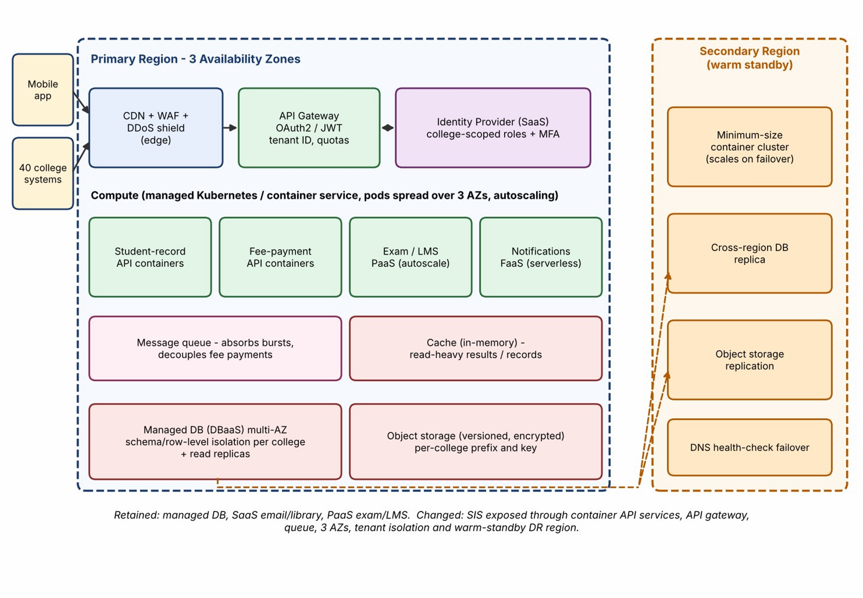
Figure 14: Revised architecture for the Day-4 requirements (modified design)
Revised architecture
- Edge and API: CDN, WAF and DDoS protection in front of an API gateway that authenticates callers with OAuth2/JWT, identifies the tenant, and applies throttling and quotas. An external identity provider (SaaS) manages user and college identities.
- Compute: student-record and fee-payment APIs run as containers on a managed Kubernetes/container service spread across three availability zones; the existing SIS monolith stays behind them and is gradually peeled off using a strangler pattern.
- Serverless: notifications, receipts and file processing move to FaaS, billed only when used.
- Queue and cache: a message queue absorbs fee-payment bursts and decouples the payment gateway; an in-memory cache and the CDN serve repeated result and record reads.
- Data: multi-AZ managed database with read replicas and per-college isolation; versioned, encrypted object storage with per-college prefixes.
- DR: warm-standby secondary region (minimum-size cluster, cross-region database replica, replicated storage, DNS health-check failover).
What changed in the service model mix and virtualization approach Table 27: Original versus revised design
Aspect | Original | Revised
SIS | IaaS VM pair | API facade as containers; monolith core stays on VMs and is gradually decomposed
LMS / Exam | PaaS | PaaS kept; limits and caching tuned for 10 x
Email / Library | SaaS | SaaS kept
Database | DBaaS multi-AZ with standby | DBaaS multi-AZ with read replicas, cache, per-tenant isolation
Virtualization | VMs and some containers on VM hosts | Container-first with orchestration and autoscaling; VMs only for legacy
XaaS | DBaaS, DRaaS | Plus API gateway, FaaS, SECaaS (WAF/DDoS), identity service and message queue
Availability design | 2 AZs, DR region as pilot light | 3 AZs, redundant instances, warmstandby DR region
Deployment model | Public cloud with hybrid transition | Public cloud; community-style shared services for colleges through tenant isolation

11.4 Evidence-based defence
Capacity calculation
Current worst-case peak = 12 servers x 95% = 11.4 SE
New peak (10x) = 11.4 x 10 = 114 SE
Capacity at 70% utilisation = 114 / 0.70 = 162.9 -> 163 SE

Assume caching, CDN and queues remove 40% of backend load (to be proven by testing):
Peak backend capacity = 163 x 0.60 = 97.8 -> about 98 instances (1 instance = 1 SE)

Baseline (non-peak) load, assuming the mobile app doubles average load:
1.8 SE x 2 = 3.6 SE -> 3.6 / 0.70 = 5.1 -> minimum 6 instances (2 per AZ x 3 AZs)

Autoscaling range: 6 instances (baseline) to about 98 instances (peak weeks).
Availability calculation
Components in series multiply: A(total) = A1 x A2 x ... Assumed component availabilities ( planning values; verify against the chosen provider's SLA ):
Original (single SIS VM 99.9%, others as shown):
LB 99.99% x API 99.95% x SIS VM 99.9% x DB 99.95% x Storage 99.99%
= 99.78% -> downtime = 8,760 x (1 - 0.9978) = about 19.3 h/year (target: 8.76 h) FAIL

Revised (redundant across 3 AZs; managed multi-AZ services at 99.99%):
Edge x API gateway x Compute x DB x Storage x Identity = 0.9999^6
= 99.94% -> downtime = 8,760 x (1 - 0.9994) = about 5.3 h/year (target: 8.76 h) PASS

Sensitivity: if the API gateway is only 99.95% the total is 99.900% = 8.76 h/year,
i.e. zero margin. Margin therefore comes from the warm-standby DR region, caching and queueing (which keep serving during partial failures), and from rolling deployments.
Cost comparison
Table 28: Annual cost at 10x load (INR lakh per year)
Item |  | Original design scaled statically | Revised elastic design
Compute |  | 146.7 (163 instances x 7,500 x 12) | 16.5 (baseline 5.4 + peak burst  11.1)
Database service |  | 12.0 | 18.0 ( multi-AZ + replicas )
API gateway, CDN, WAF |  | - | 8.0
Cache, queue, FaaS |  | - | 5.0
Storage |  | (incl. above) | 10.0
DR / backup |  | 6.0 | 7.0 ( warm standby )
Item |  | Original design scaled statically | Revised elastic design
Data transfer |  | 9.0 | 9.0
Identity and email SaaS |  | (incl. above) | 8.0
Monitoring |  | - | 3.0
Staff |  | 24.0 (3) | 24.0 (3 engineers; more DevOps skills)
Annual total |  | 197.7 | 108.5
3-year total (incl. onetime migration) |  | 611.1 (18 one-time) | 355.5 (30 one-time)
Peak burst = 55 extra instances (average) x 1,344 h (8 weeks) x Rs 15/h = Rs 11.1 lakh
Baseline = 6 reserved instances x Rs 7,500 x 12 = Rs 5.4 lakh
Revised 3-year = 30 + 3 x 108.5 = 355.5 lakh Original scaled 3-year = 18 + 3 x 197.7 = 611.1 lakh
Saving = (611.1 - 355.5) / 611.1 = 41.8%
Because the peak lasts only about 8 of 52 weeks (15% of the year), paying for peak capacity all year (original, scaled statically) is the main cost driver; elasticity cuts it by roughly 42%. Affiliated colleges can also be charged per student through metered tenant usage, which would reduce the net cost to the university; this has not been included in the figures.
Security and multi-tenancy considerations
Tenant-scoped tokens, per-tenant row-level isolation, separate encryption keys or prefixes, per-tenant quotas, WAF/DDoS protection and audit logs (Section 11.1). A tenant-isolation test (college A must never read college B's records) should be part of the acceptance tests.
Trade-offs
Table 29: Trade-offs of the modified design
Trade-off | Consequence | Mitigation
Vendor lock-in | Managed gateway, queue and FaaS are provider-  specific | Containers and standard SQL for core logic; OpenAPI contracts; documented exit plan.
Complexity | More components, more skills required | Infrastructure as code, managed Kubernetes, training, observability from day one.
Trade-off | Consequence | Mitigation
Migration effort | Strangler decomposition of the SIS takes time | Phase it: API facade first; deliver the mobile app on the new layer; decompose gradually.
Cost versus resilience | Warm standby and 3 AZs add cost | Minimum-size standby; scale on failover; reserved baseline capacity.
Unvalidated assumptions | 40% offload, 98-instance peak and SLA values are estimates | Load-test at 10x before launch and tune; re-run this analysis with measured figures.
Final decision
Modify, not retain or redesign: the strategic choices from Tasks 1-10 still hold (public cloud, managed services first, DBaaS and DRaaS, phased migration), and the changes needed are the API gateway and tenant isolation, container-based elastic compute across three zones, a queue and cache, and a warm-standby DR region. The analysis shows this meets the 99.9% target on paper (about 5.3 h/year of expected downtime), at about 42% lower three-year cost than scaling the original design. All capacity and availability values must be confirmed by load testing and the provider's actual SLAs before launch.

Task Cross-Reference for the Evaluator

This table only points to where each task is answered. The marks (Awarded column) are to be given by the evaluating faculty and are intentionally not filled in here.
Table 30: Where each task is answered in this report
Task | Title | Max | Main evidence in this report
1 | Introduce Cloud Computing | 3 | Definition, 5 characteristics, deployment models, problem mapping figure and table
2 | Evolution and  Hardware Evolution | 3 | Timeline figure, stage table, hardware table, stage of current system
3 | Internet Software Evolution | 3 | Evolution table, desktop vs client-server vs web comparison, design effects
4 | Server Virtualization | 5 | Hypervisor/container figure, comparison tables, step-by-step consolidation calculation
5 | Web Services | 4 | SOAP vs REST table, three APIs with request/response, flow figure
6 | IaaS, PaaS, SaaS | 5 | Responsibility figure and table, fiveapplication mapping with reasoning, comparison
7 | XaaS | 3 | Six variants, DBaaS and DRaaS justified, over-reliance risks
8 | Cloud Solution  Architecture | 5 | Labelled architecture figure, component table, scaling figure, security
9 | Hands-on Implementation | 4 | Code, steps, tested outputs; screenshots to be inserted by the student
10 | Evaluate and  Recommend | 7 | Three-way comparison, 3-year cost table and charts, risks, roadmap
11 | Day-4 Design  Challenge | 8 | Impact, evaluation, revised architecture figure, calculations, cost, trade-offs

References and Notes

- Mell, P. and Grance, T., The NIST Definition of Cloud Computing, NIST Special Publication 800-145, 2011.
- Course material for CSA15 - Cloud Computing and Big Data Analytics, Saveetha Institute of Medical and Technical Sciences.
Provider documentation (AWS, Microsoft Azure, Google Cloud) should be consulted for the current service levels and pricing used in the cost and availability estimates; the figures in this report are

